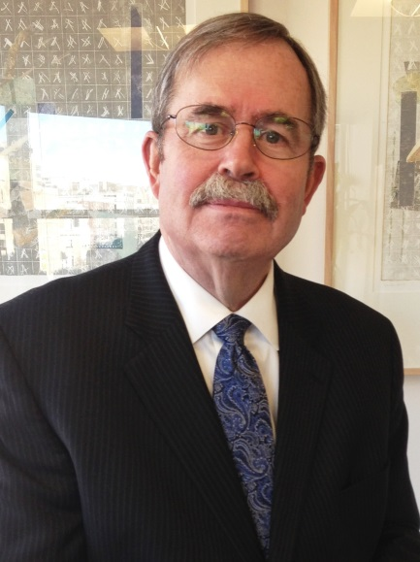
KEYNOTE SPEAKER
OPENING PLENARY
FRIDAY JUNE 6, 2014

Michael Randolph Brower
President and Chief Executive Officer, American Council On Renewable Energy (ACORE)

Michael R. Brower was unanimously elected to be the third permanent President and CEO of ACORE by the Board of Directors on December19, 2013. He had served as ACORE’s Interim President and CEO after Vice Admiral Dennis McGinn was named by President Obama to be the Assistant Secretary to the Navy for Energy, Installations and the Environment in July 2013. A former ACORE Board member, Mr. Brower has decades of experience in renewable energy policy, project development, finance and market development. He now leads the organization for implementation of the Board of Directors-ratified strategic plan, directing ACORE’s operational policy and practice; as well as, internal and external relations including financial matters and industry-wide coordination, communications and cooperation.

An experienced executive leader, Washington/Capitol Hill veteran and renewables advocate with a proven multi-sector senior leadership record, Mr. Brower is a thought-leader and diplomatic communicator known for promoting and advancing every aspect of energy literacy. He helped craft the first ever Energy Title (IX) in the Farm Security and Rural Investment Act of 2002, and played a direct role shaping biomass definitions and tax components in the Energy Policy Act of 2005, the Energy Infrastructure and Security Act of 2007, and the Food, Conservation and Energy Act of 2008. Additionally, Mr. Brower was involved in helping enact the Section 1603 Cash Grants In Lieu of Tax Credits language in the American Recovery and Relief Act of 2008, and the inclusion eligibility for biomass and geothermal technologies for Investment Tax Credits in the American Taxpayer Relief Act of 2012.

He enjoys extensive project development experience with biomass, energy crops, wind, geothermal, distributed generation, district heating and cooling, solar, biomass conversion to liquid fuels projects and across his career has developed significant extramural funding for every manner of renewable energy project, regardless of technology.

Most recently, Mr. Brower was appointed to the United States Energy Security Council, joining a notable cadre of 32 federal and state executive and legislative elected, post-cabinet leaders, a Nobel Prize winner and retired military flag officers that include Alan Greenspan, Governor Linda Lingle, T. Boone Pickens, and Robert “Bud” McFarlane. An accomplished international and national speaker, Mr. Brower recently keynoted the China Renewable Energy Conference in Wuxi, China and ACORE’s REFF-West in San Francisco.

In January 2006, he helped establish Mosaic Federal Affairs LLC, as a wholly-owned subsidiary of the New York law firm Hiscock & Barclay LLP. He is a retired career Naval Officer and Aviator who commanded Sea Strike Squadron Twenty-Two in the first Iraqi War and flew 43 aircraft carrier-based combat sorties during that conflict. Mr. Brower also served in the Secretary of the Navy’s office as Special Assistant for Air Warfare communicating United States Navy legislative policy to the Congress. After his two decade-plus career in naval service, he was a state agency executive director, bank director, farmer, a federal and New York State legislative affairs consultant and Director, Community and Governmental Relations at SUNY College of Environmental Science and Forestry (SUNY-ESF).
He now lives in Washington, DC.

